**Experiment Title:** Familiarization with a microcontroller, the study of blink test and implementation of a traffic light control system using microcontroller and Proteus.

# Objectives:

The objectives of this experiment are to-

* 1. Familiarize with the Arduino microcontroller
  2. Implement a simple circuit to make LED lights blink using delay function
  3. Implement a simple traffic control system
  4. Simulate a microcontroller-based system using Proteus

# Equipment List:

|  |  |
| --- | --- |
| 1) Arduino IDE (any version) | Software |
| 2) Arduino Uno (R3) board or Arduino mega 2560 board | Image result for arduino mega  pin configurations |
| 3) LED lights (RED,GREEN and YELLOW) and three 200 ohms resisters and jumper wires | Image result for green red yellow led light |

# Circuit Diagram:

Explain the circuit diagram here for Figs. 1 and 2.

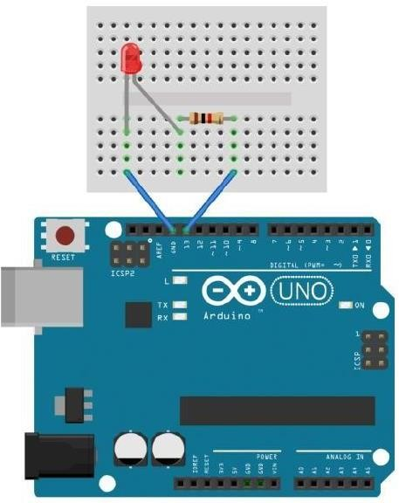

# Figure 1: Hardware circuit diagram for the blink test.

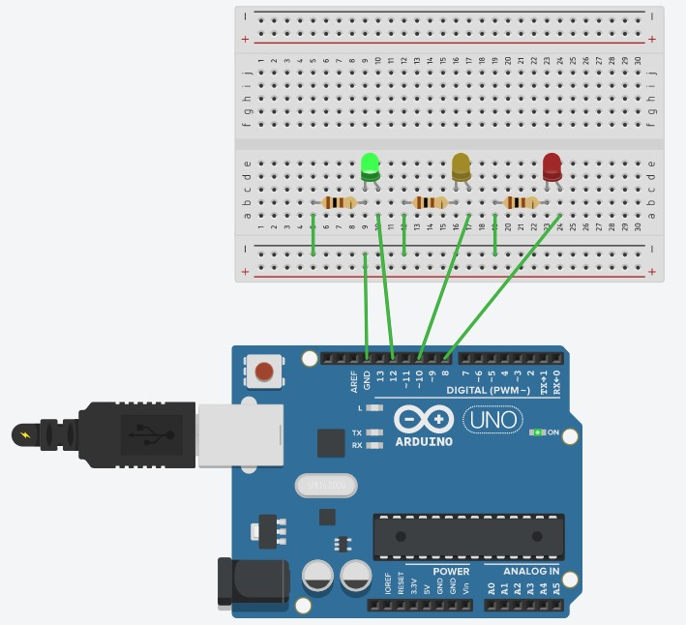

**Figure 2: Hardware circuit for traffic light control system**

# Simulation Methodology and Setup:

Fig: Simulation Circuit for LED Blink test

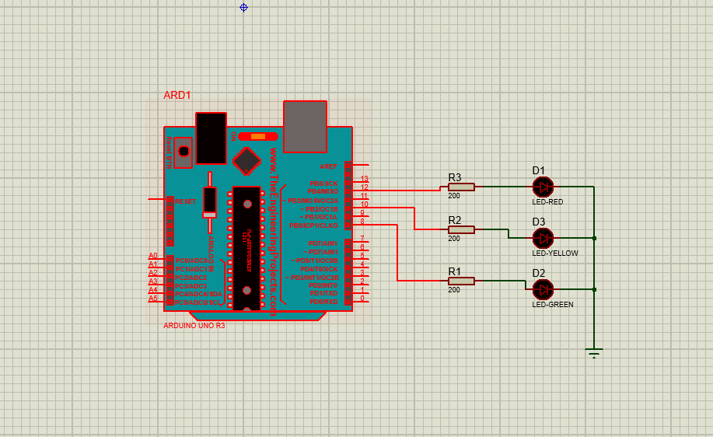

Fig: Simulation for Traffic Light Control System

In this setup for simulation, we first had to get the Arduino Uno R3 library for the proteus as it is not provide in the installation package. Then just as the Hardware part, we placed every components one by one to recreate the whole environment. To start the process, after the placement of the components, we ran the code command in the Arduino IDE and converted the file in the HEX or hexadecimal format. Afterward, we returned to proteus and uploaded the HEX file onto the micro controller. Thus the process was complete and we started to conduct the simulation.

# Assembly Codes and Explanation:

**Program to a blank sketch for the blink test for Figure 1.**

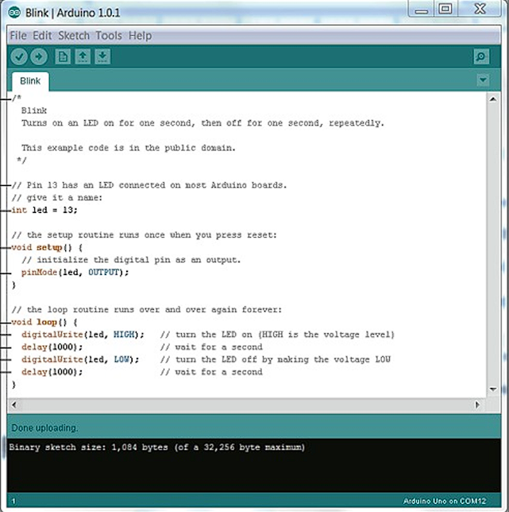

# Program for Traffic Control system for Figure-2:

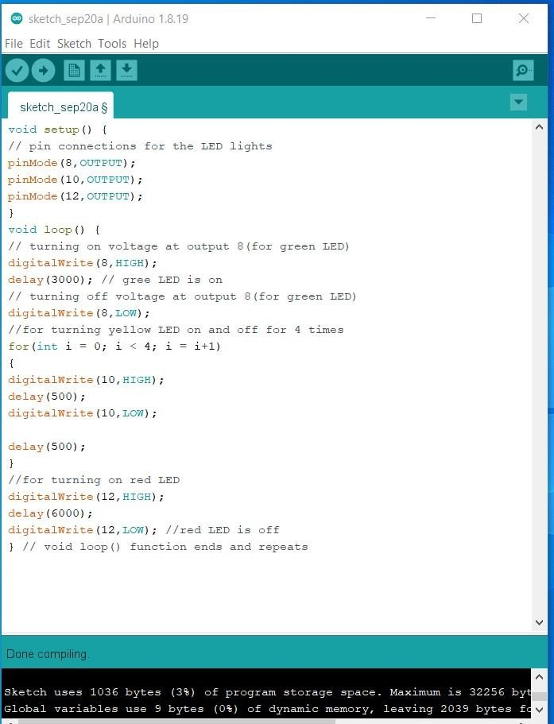

**Code Explanation:**

To develop this blink test, first, we used Arduino Uno and for writing logical code, we used Arduino IDE. Using Arduino IDE, we uploaded our program to the Arduino Uno board and then the system executed the commands. We use some built-in function on that logical code to write our own logical expression. In our experiment, we first did the blink test where we used one red led. We first defined which pin we are going to use for the output. We selected the 5th pin for the output inside the setup method. In the loop method, we used the digitalWrite method to write High or Low for the pin. Then used the delay method to set the time interval between low and high which was set to 1s. Accordingly in the traffic light system, we took three LEDs which are green, yellow, and red, and assigned them to pin numbers in the setup method. After that, we wrote the initial delay and high and low commands of the lights. We also added a function to make the yellow light blink in between. Some major functions and their works are mentioned below,

* 1. **pinMode():** Configures the specified pin to behave either as an input or an output.
  2. **digitalWrite():** It writes some value, and this value will be in the form of 0 and 1. In other words,thisfunction is mainly used to control any device attached to the Arduino by assigning value to the pin of Arduino to which that respective device is attached.
  3. **delay():** It pauses the program for the amount of time (in milliseconds) specified as parameter. (There are 1000 milliseconds in a second.

# Output Results:

**Hardware Output:**

# For Blink Test:

**Figure 3: The Red LED is OFF.**

# Figure 4: The Red LED is ON (its blinking).

**For Traffic Control system (design):**

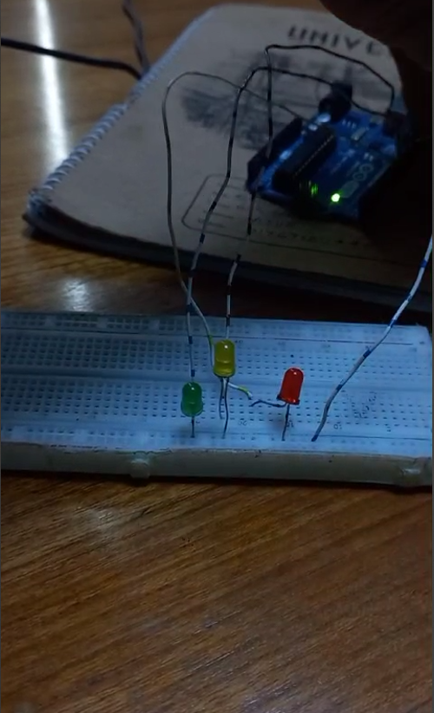

# Figure 5: The Green LED, Yellow LED and Red LED is OFF.

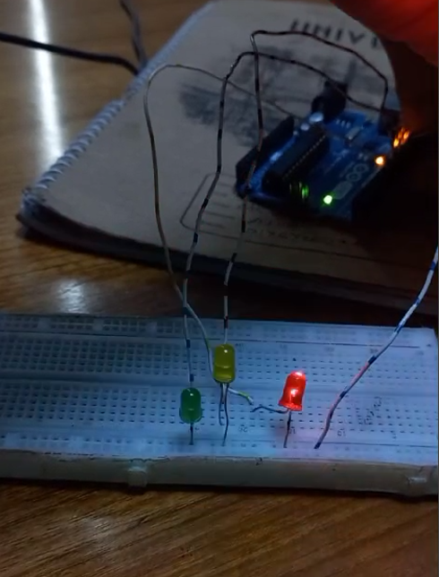

**Figure 6: The Red LED is ON.**

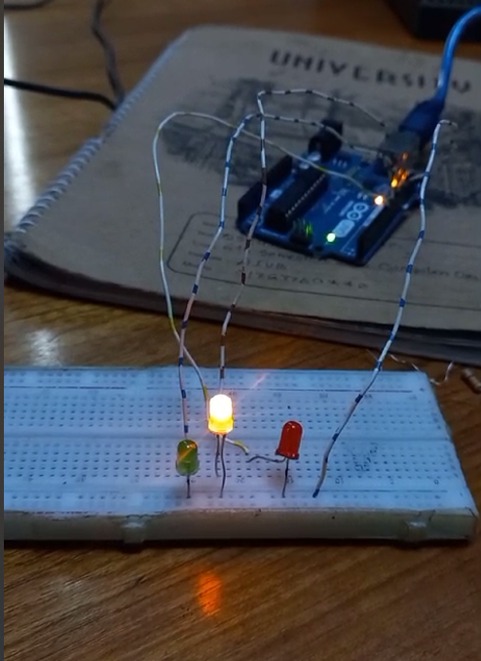

# Figure 7: The Yellow LED is ON.

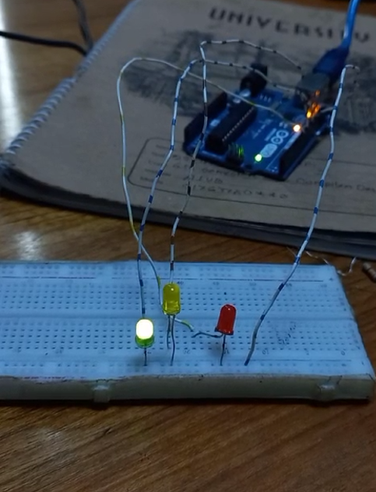

**Figure 8: The Green LED is ON.**

# Software Output:

**In Proteus, an Arduino Uno (R3) is used to implement a blink test:**

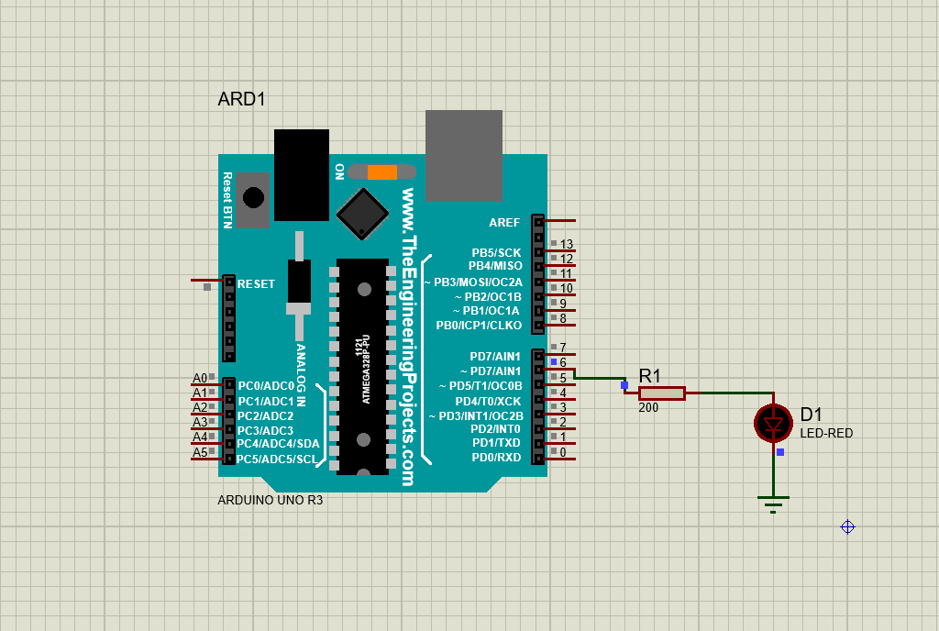

# Figure 9: The Red LED is OFF.

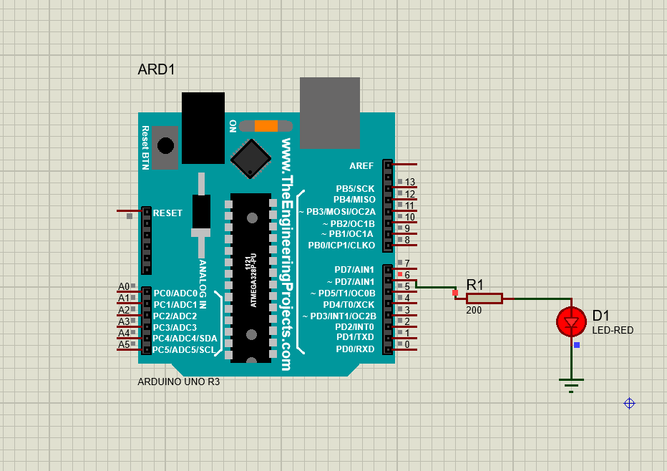

**Figure 10: The Red LED is ON (its blinking).**

# In Proteus, an Arduino Uno (R3) is used to implement a traffic control system (Design):



**Figure 11: The Green LED, Yellow LED and Red LED is OFF.**

# After build up the code, we can run simulation the project,

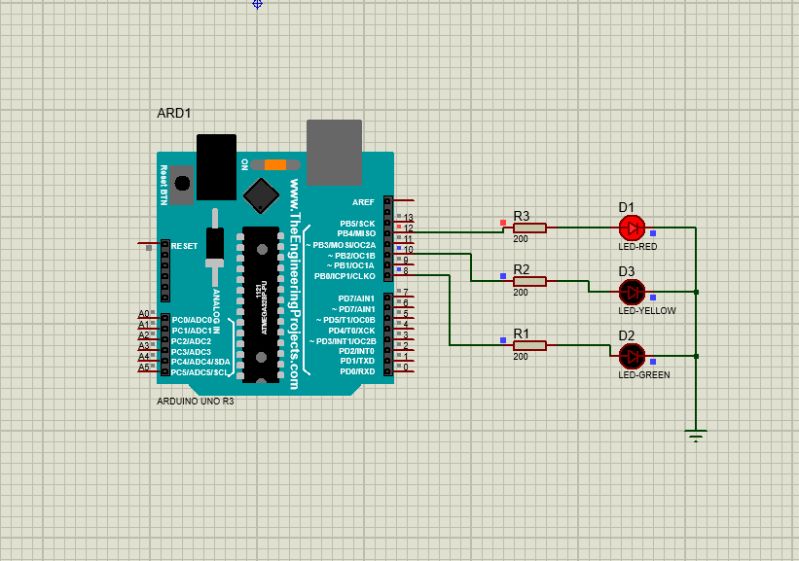

**Figure 12: The Red LED is ON.**

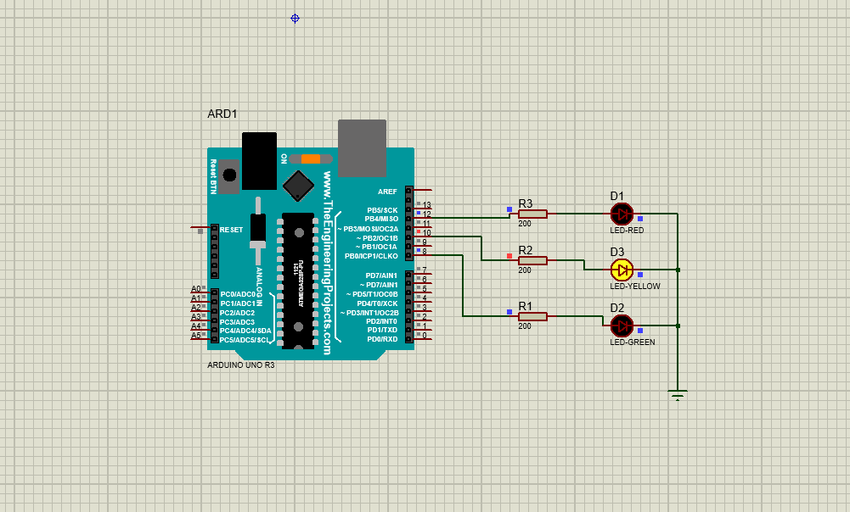

# Figure 13: The Yellow LED is ON.

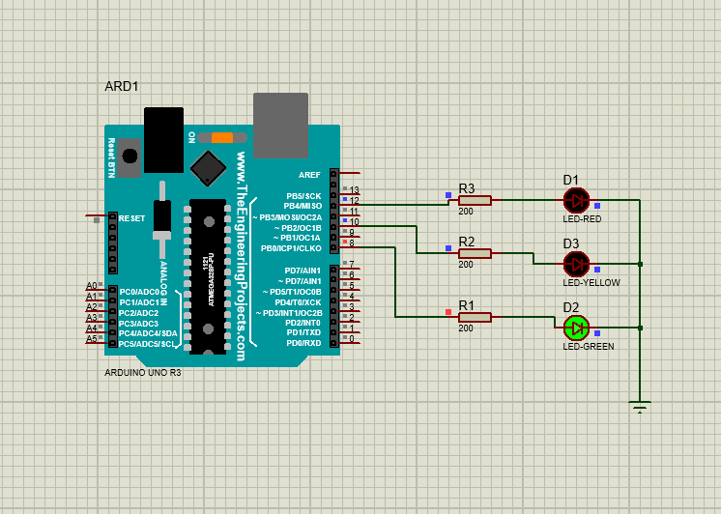

**Figure 14: The Green LED is ON.**

**Discussion:** The traffic control system was developed using an Arduino UNO at the time of this test, and the microcontroller was well-known. Our course instructor guided us through the procedure and assisted us in running this code properly. We made a circuit with 3 LED light RED, YELLOW and GREEN had been taken with 3 resisters along with a breadboard. The resistors had been taken to ground. After designing the circuit, the code was implemented. Codes were written with Arduino IDE where LED blink and delay functions were added into the codes. After writing the codes and simulating it, the code ran successfully and the result had been recorded.

**References:**

1. https://[www.arduino.cc/.](http://www.arduino.cc/)
2. https://[www.coursera.org/learn/arduino/lecture/ei4ni/1-10-first-glance-at-a-program](http://www.coursera.org/learn/arduino/lecture/ei4ni/1-10-first-glance-at-a-program)
3. Jeremy Blum; Exploring Arduino: Tools and Techniques for Engineering Wizardry.